74HC595 74HC164 8Bit 8-Digit LED Nixie tube Display Module Red Digital Tube

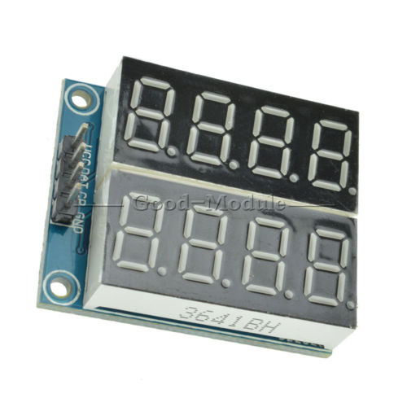

**Description:**

1, onboard two-way 74HC164 serial-to-parallel chip

2, on-board 2-way 0.36 inches red common anode four 8-segment

3, onboard cascade control interface for easy connection of external devices

4, the working voltage: 5V

5, board size: 35.3 (mm) x29 (mm)

Notes:

Like many things cheap from China, there is no documentation for this.

Most of the code I found (which may or may not work) has a 3rd pin for the latch function

This board only has “DAT” and “CP” - which I am assuming means DATA and CLOCK PIN

Googling this only brings up sellers selling it… the code found is either generic code for the 74HC595 or for a different board.

This is interesting code, but not for this display

<http://tronixstuff.com/2012/04/09/arduino-and-tm1640-led-display-modules/>

These two sites are the closest I’ve found to “working” code - however it still not 100% correct and is something to play with.

<http://lucidtronix.com/tutorials/41>

<http://lucidtronix.com/tutorials/50>